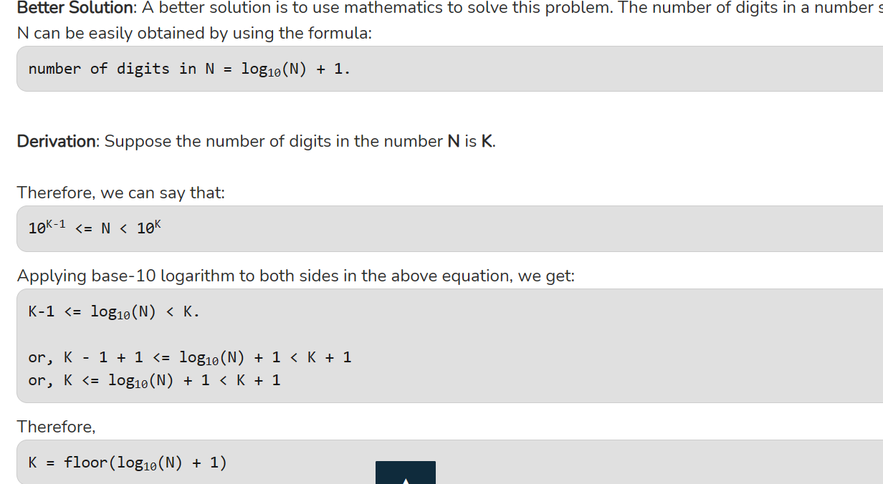

|  |  |  |
| --- | --- | --- |
| **Operator** | **Description** | **Associativity** |
| **( )  [ ]  .  ->  ++ –  –** | **Parentheses (function call) (see Note 1)  Brackets (array subscript)  Member selection via object name  Member selection via pointer  Postfix increment/decrement (see Note 2)** | **left-to-right** |
| **++ –  –  + –  ! ~  (*type*)  *  &  sizeof** | **Prefix increment/decrement  Unary plus/minus  Logical negation/bitwise complement  Cast (convert value to temporary value of *type*)  Dereference  Address (of operand)  Determine size in bytes on this implementation** | **right-to-left** |
| **\*  /  %** | **Multiplication/division/modulus** | **left-to-right** |
| **+  –** | **Addition/subtraction** | **left-to-right** |
| **<<  >>** | **Bitwise shift left, Bitwise shift right** | **left-to-right** |
| **<  <=  >  >=** | **Relational less than/less than or equal to  Relational greater than/greater  than or equal to** | **left-to-right** |
| **==  !=** | **Relational is equal to/is not equal to** | **left-to-right** |
| **&** | **Bitwise AND** | **left-to-right** |
| **^** | **Bitwise exclusive OR** | **left-to-right** |
| **|** | **Bitwise inclusive OR** | **left-to-right** |
| **&&** | **Logical AND** | **left-to-right** |
| **| |** | **Logical OR** | **left-to-right** |
| **? :** | **Ternary conditional** | **right-to-left** |
| **=  +=  -=  *=  /=  %=  &=  ^=  |=  <<=  >>=** | **Assignment  Addition/subtraction assignment  Multiplication/division assignment  Modulus/bitwise AND assignment  Bitwise exclusive/inclusive OR assignment  Bitwise shift left/right assignment** | **right-to-left** |
| **,** | **Comma (separate expressions)** | **left-to-right** |

🡪Prime

* **Except for 2, which is the smallest prime number and the only even prime number, all prime numbers are odd numbers.**
* **Every prime number can be represented in form of 6n + 1 or 6n – 1 except the prime numbers 2 and 3, where n is a natural number.**
* **Two and Three are only two consecutive natural numbers that are prime.**